Supplemental Information Regarding Interpretation of CA Plot

General Idea of CA

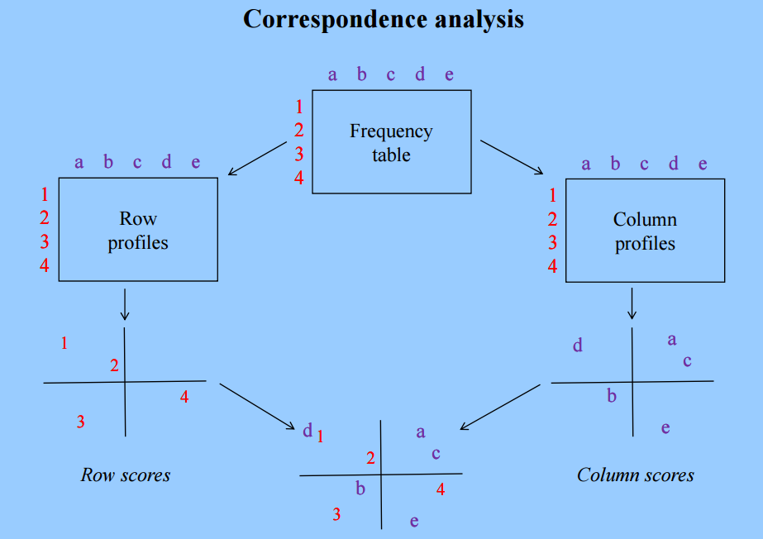

Typical CA Plot

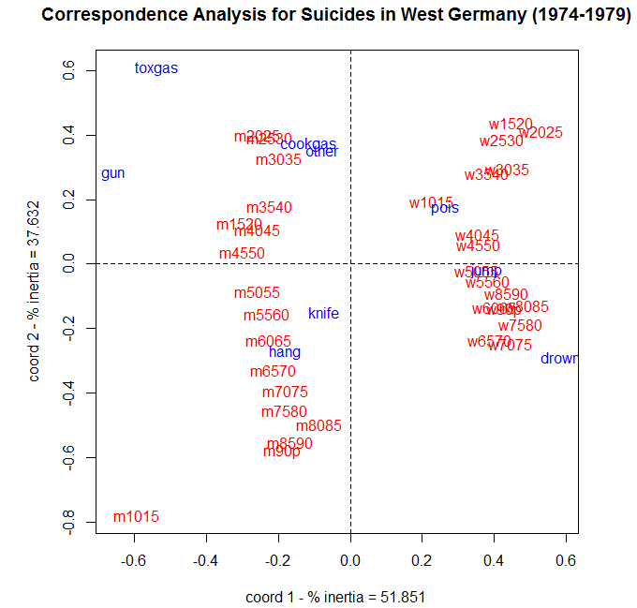

Some initial comments regarding the intrepretations of this plot…

Source: NCSS Statistical Software, Chapter 430 Correspondence Analysis

|  |  |  |
| --- | --- | --- |
| Rows Only |  | When considering the dimension reduction happening on the rows…   * Proximity matters * Rows close to one other are similar in the higher dimensional space, e.g. Gender/Age w6570 and w7075 are very similar to each other * Gender/Age m1015 is not similar to any other Gender/Age * Points “close” to the origin indicate little to no association |
| Columns Only |  | When considering the dimension reduction happening on the columns…   * Proximity matters * Rows close to one other are similar in the higher dimensional space, e.g. Gun and Toxic Gas are more similar Gun and Drowning * Points “close” to the origin indicate little to no association and should not be considered |

When investigating the associations between rows and columns in a Correspondence Analysis plot, two things must be considered

* The distance from the orgin
* The angle between the row label and column label

|  |  |
| --- | --- |
| Description: Strong Postive Association - long rays, angle small, i.e. cos(angle) near 1 | |
| Description: Not as strong positive - one shorter ray, angle larger | Description: No association - angle very large |
| Description: Fairly strong negative - longer rays, angle near 180 | Description: No association - short rays |